ACS ACCREDITATION MANUAL

Volume 3: Application Template

TABLE OF CONTENTS

1 INTRODUCTION 3
1.1 Terminology 4
2 STANDARD OF APPLICATION 6
3 APPLICATION TEMPLATE 6
1. Accreditation Request 7
2. Institutional Context of ICT Programs 8
2.1 Institutional Commitment to ICT Education 8
2.2 ICT Academic Leadership and Staffing 8
2.3 ICT Student Profile 9
2.4 Technological Resources for ICT Education 9
2.5 Monitoring, Review and Improvement 9
2.6 Action from Previous Accreditation 9
3. ICT Program Specification and Implementation 10
3.1 ICT Program Specification 11
Criterion A. Program Design 11
Criterion B. Professional ICT Role and Skills 13
Criterion C. Coverage of ICT Knowledge 14
Criterion D. Advanced ICT Knowledge Addressing Complex Computing 14
Criterion E. Integrated and Applied ICT Knowledge and Skills 16
Criterion F. Preparation for Professional ICT Practice 16
3.2 ICT Program Implementation Pathways 17
Version History 18

1 INTRODUCTION

The Australian Computer Society (ACS) is the authority responsible for the accreditation of professional ICT education programs in Australia.

The ACS is accredited by the International Professional Practice Partnership (IFIP IP3).

The ACS is a signatory to the Seoul Accord. The Accord signatories accord mutual recognition to their respective accreditation schemes for undergraduate and postgraduate (master’s level) (degree) programs for initial professional practice. The Seoul Accord Graduate Attributes have been incorporated within the ACS Core Body of Knowledge (2015, Appendix D). This mapping ensures that a program satisfying the ACS accreditation criteria will satisfy the Seoul Accord criteria and forms the substance of the ACS adherence to the Accord.

The ACS complements the role of Australia's Tertiary Education Quality and Standards Agency (TEQSA) and accredits higher education programs in ICT as a discipline-specific application of the Higher Education Standards Framework (Threshold Standards).

The ACS Accreditation system is specified in 3 volumes:
Volume 1: Accreditation Procedure
Volume 2: Accreditation Criteria
Volume 3: Application Template

This document, ACS Accreditation Manual Volume 3: Application Template has been created to assist educational Institutions to prepare their accreditation application. These guidelines must be read in conjunction with the
ACS Accreditation Manual: Volume 2: Accreditation Criteria.

The key objective of the Application documentation is to provide primary evidence that a program and its institutional context satisfies the accreditation criteria set for assessment of professional ICT education programs. The submitted documentation will be a coherent self-analysis, reporting against the criteria for accreditation. Each criterion must be addressed in a definitive manner and be sufficient for the evaluation panel to form a judgment on it.

The accreditation process is focused on systems and programs that are already in place, not to require their creation. To this end much of the documentation requested should already exist and not require specific research or development. Wherever possible, applicants should link to existing digitally accessible resources rather than replicate them.

1.1 Terminology

For the purposes of the ACS Accreditation Manuals the following terminology is used:

AC The Accreditation Committee of the ACS.

ACS The Australian Computer Society.

AQF Australian Qualifications Framework (https://www.aqf.edu.au).

Accreditation Types
Accreditation recognises programs that prepare graduates for professional practice in ICT. Professional level for initial practice and Specialist accreditation for expertise in a particular specialisation (see Volume 2, Sections 3.2 and 3.3).

CBoK ACS Body of ICT Knowledge

SFIA Skills Framework for the Information Age, current version
(https://www.sfia-online.org/en).

Bloom’s Taxonomy Anderson, Lorin W (2001) A Taxonomy for Learning Teaching and Assessment: Revision of Bloom's Taxonomy of Educational Objectives Longham.

HESF Higher Education Standards Framework 2015
(https://www.teqsa.gov.au/higher-education-standards-framework-2015).

TEQSA Tertiary Education Quality and Standards Agency (https://www.teqsa.gov.au/).

IFIP IP3 International Federation of Information Processing; International Professional Practice Partnership (https://www.ipthree.org).

Seoul Accord Seoul Accord establishes international standards for ICT graduate outcomes and a basis for international recognition of ACS accredited programs (http://www.seoulaccord.org/).

Institution The Higher Education provider that is responsible for, or is applying for, the accreditation of an ICT program.

ICT School That part of the Institution responsible for the education of ICT graduates.

ICT Industry Advisory Board
A body to provide advice on industry requirements of ICT graduates, program content, industry trends and the institutions interactions with industry.

ICT Industry Liaison
A role in the institution with oversight of industry interaction with a program, including organising ICT Industry Advisory Board meetings and consultations; industry projects, internships and placements; industry guest lectures, visits and so on.

Program A structured set of subjects and/or majors leading to a recognised AQF
qualification. In some institutions a program is called a course, or a degree.

Development Plan An institution’s schedule of activities and plans to address any issues that may affect ACS accreditation.

Specialisation An area of the ICT field nominated by the ACS for specialist accreditation (see Accreditation Manual Volume 2, Section 3.3).

Major/ Minor A structured set of subjects which address the complexities of a specific part of the ICT field.

Subject A subject is also known as a course or unit. It is a component of a program in which a coherent body of knowledge taught and assessed as a whole. Where quantification is required, a subject is one eighth of one Equivalent Full-Time Student Load (EFTSL) being ‘a measure of the study load, for a year, of a single student undertaking a course of study on a full-time basis’ (https://www.teqsa.gov.au/glossary-terms).

ICT Subject A subject which assesses knowledge from CBoK (see Accreditation Manual Volume 2, Criterion C).

ICT-related Subject A mandatory subject with little ICT content may be considered ICT-related if it is necessary for the achievement of a program's ICT discipline-specific knowledge (Criterion C). The types of ICT-related subjects are:
subjects from 'reference disciplines' provide theoretic or methodological background to ICT - eg. discrete maths to database, logic to knowledge-based systems, perceptual psychology to HCI, stats to analytics.
subjects from 'application disciplines' subjects that situate or specialise ICT - eg. health data specification, business analytics algorithms.
An ICT-related subject has a genuine relationship with specific ICT subjects. It needs to be clear how an ICT student's ICT disciplinary knowledge (not capacity in a professional role) is enhanced by an ICT-related subject. An ICT-related subject cannot merely provide a context for ICT to be applied.

Wherever possible the ACS will use the terminology of the institution seeking accreditation, however, for consistency, the above terminology is used throughout the Accreditation Manual.

2 STANDARD OF APPLICATION

The Seoul Accord, an agreement between signatory countries, recognises comparability of accreditation systems and standards for professional ICT programs. The Accord is maintained through an ongoing program of mutual inspection and validation. It is possible at any time that the process of ACS accreditation of programs within any Australian institution may be subject to scrutiny and/or participation by observers from other Seoul Accord signatories.

Applications must be of a suitable standard for international audit. If the initial documentation is not considered to meet the following guidelines, the Institution may be asked to resubmit before a visit is scheduled.

3 APPLICATION TEMPLATE

The Template below is recommended as a means to present the data needed for accreditation.
The template contains:
- headings matching the criteria specified in Volume 2
- blue italicised text providing explanation and suggestions to help in completing each section.
To use the template, delete the blue italicised text when you have completed the section.

As the Accreditation Panel may at any stage request further information, provide only what the template asks for.

1. Accreditation Request

Institution: | Provide the full name under which the Institution operates and confers the qualifications resulting from the programs to be accredited.
Name of Institution
CEO
Institution Address
Telephone
Institution Web Site

ICT Teaching entity: |  | Provide details of the college/faculty/school/department structure responsible for offering the program(s) for accreditation. Room is provided to allow a three-level description of the organisation entity - please provide the type of entity (e.g. faculty or department) and its name (e.g. School of Computing and Mathematical Sciences).
Level 1
Level 2
ICT Teaching Entity
ICT Entity Web Site
Head, ICT Teaching Entity
Address
Telephone
E-mail address

Programs: | Provide a list of programs submitted for accreditation.  Level refers to the level of award (e.g. AQF 7, AQF 8, AQF 9).  Type refers to the ACS accreditation sought (Professional, Specialist).
Title of Program |  | Campus | Level | Type

Institution Contact: | Provide details of the primary contact and person responsible for this application.
Name
Title
Address
Telephone Number(s)
E-mail address

2. Institutional Context of ICT Programs

This section of the template identifies the sort of evidence that the institution can provide which would allow the Accreditation Panel to assess the institutional context for ICT Education. Where the institution provides links to documents or information, please ensure that the appropriate permissions to the relevant sections of the institution’s systems are available to ACS panellists.

2.1 Institutional Commitment to ICT Education

Strategic Statement of Institutional Support

Linking to an Institution mission statement and strategic plans may provide evidence of the Institution’s long-term commitment to ICT. If necessary, a statement from the institution's president or CEO may be needed.

ICT School Planning and Review

Documents embodying the School’s strategic directions for ICT education, industry engagement, research and other professional activities are useful evidence.
Include the Development Plan if one was created during the School's self-analysis (see Accreditation Manual Volume 1 Section 3).
Link to documents associated with the most recent School or curriculum review.

The ICT School – Structure and Institutional Context

In order for the panel to better understand the larger context of ICT programs, outline the organisational structure of the School, including management roles and incumbents, and how it interacts with the institutional structure (Faculty and Institutional committees, etc).

Educational Location and Partnerships

List all campuses at which this program is offered. Include online as a separate campus.

2.2 ICT Academic Leadership and Staffing

Leadership

Provide evidence in response to this accreditation criterion.

Staffing

Link to the staff directory for the ICT School.

Staff Qualifications

Where the staff directory does not include qualifications, link to a short CV for each staff member, including casuals.

2.3 ICT Student Profile

While there are no specific ICT accreditation criteria beyond HESF Section 1.3, the panel needs to have an understanding of the student profile. Link to an indication of the EFTSL in each program by campus and data concerning student progression (admission and graduation data). The data should indicate student gender and whether they are domestic or international.

2.4 Technological Resources for ICT Education

Identify specific ICT facilities, including laboratories, specialised technology and software in active use for teaching and the level of student access to them.
Show how these facilities are related to current industry practice.
Indicate the technical support for these facilities and the training for staff.
Link to school policies regarding the use of technology in education.

2.5 Monitoring, Review and Improvement

Link to QILT data for each program and internal data used in program monitoring.
Link to the mechanism(s) for seeking advice from the ICT industry, alumni, the community and professional bodies. Link to agendas and minutes of meetings of the ICT Industry Advisory Board demonstrating their input into program.
Link to recent internal reviews of the ICT School and its program. Any responses to other accrediting bodies including TEQSA may be useful.

2.6 Action from Previous Accreditation

Provide a response to the recommendations of the previous accreditation.

3. ICT Program Specification and Implementation

This section of the template identifies the information that specifies each program. In this section of the template demonstrate how the program has been structured to develop the Professional Knowledge, Skills and Application of knowledge and Skills required to achieve the program's ICT professional objectives.

Prepare one response for each program.
Where there are multiple majors within a program which target different professional roles,
prepare one specification for each major.

Program Details

Program Code:
Award Title on Testamur:
Award Title on Transcript:

Personnel

Program Coordinator:
ICT Industry Liaison:
Key academic staff: Identify the key staff who are expert in the discipline and profession addressed by the program (especially those involved in teaching subjects identified as addressing Criteria D and E)

Key Staff
Subject Code & Title | Staff member

Link to a short CV for these staff members, to provide evidence of their expertise. Include current engagement with industry (consultancies), with their discipline (eg. Special interest groups, editorships) and the profession (eg. ACS networking).

Access to Documents and Teaching Materials

Provide a link to the institution-approved document(s) that specify the program and each subject including, or as well as, all assessment items and how they are matched to subject learning outcomes.

Provide read-only, auditor level access to the Learning Management System. This access is used to review and assess the teaching and learning as it applies to accreditation criteria.

3.1 ICT Program Specification

Criterion A. Program Design

Program Objective and Outcomes

Provide a link to the institution-approved document(s) that specify the program's approved objectives and learning outcomes (including the institution’s graduate outcomes), entry requirements and structure.
Provide links to other relevant published material that refer to the program (advertising, etc).

Program Components and Structure

Link to, or if necessary, create, information that identifies:
- mandatory ICT subjects, elective ICT subjects and non-ICT subjects (perhaps use colour coding)
- prerequisite knowledge links (both hard prerequisites and assumed knowledge).
A sample diagram is:
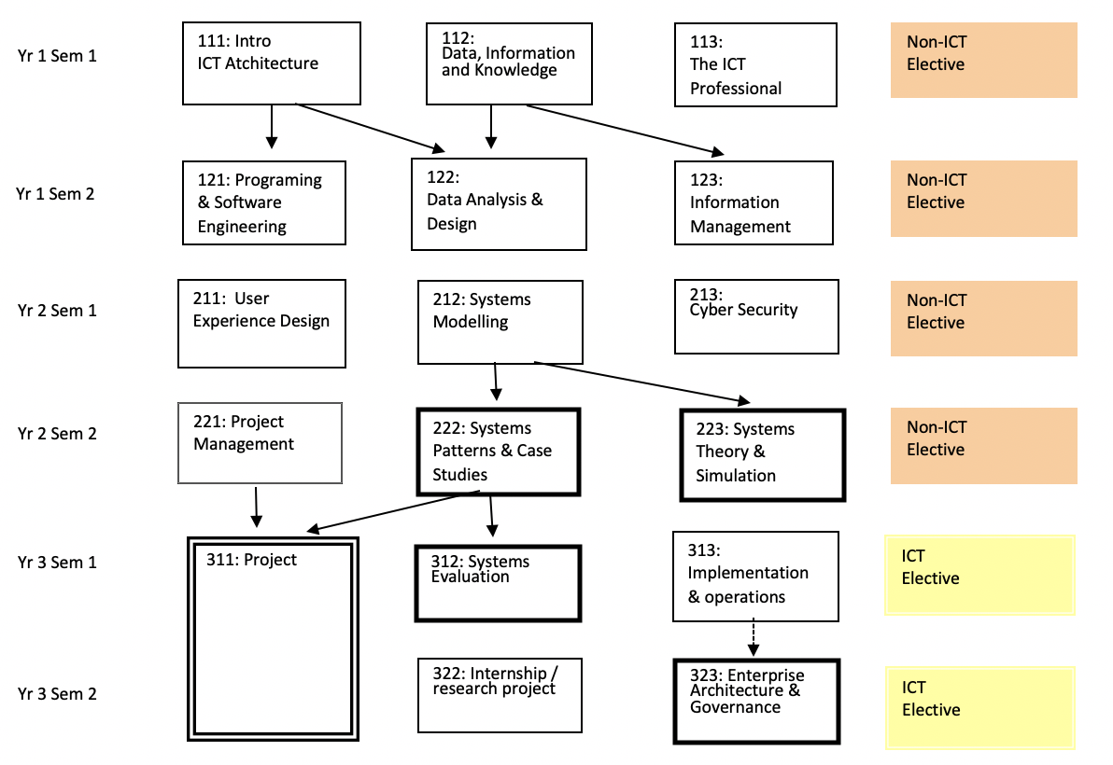

SAMPLE

In this sample the darker border on boxes denotes Advanced Subjects (see criterion D) and
the double border on boxes to denote Integrated and Applied subjects (criterion E). Arrows show prerequisites, dotted arrows show assumed knowledge.

Provide a list of any mandatory ICT subjects that may be sourced from external providers (eg. through articulation arrangements, partnerships, etc.)

Justification of Program Design

a) Show the coherence of title, objectives, components and structure that align with the attributes of the graduate and the student intake. Explain how the assessment of individual subject learning outcomes aggregate to ensure that learning outcomes for the program as a whole are met.

b) Provide a link to documents (perhaps a recent program review) that justifies the program. In particular, how the program:
- is related to needs of future stakeholders including the target ICT industry and the community
- responds to international curricula (see also Criterion C)
- compares with programs of a similar nature available nationally or internationally
- embodies good program design practices from current academic literature on ICT education
- embodies trends in professional practice.
Link to any further documents about the program that may assist the panel to evaluate its fit with its professional environment.

Criterion B. Professional ICT Role and Skills

Identify the primary ICT professional role that a graduate is equipped to perform on graduation. While aspirational roles (such as CIO, project manager) have a purpose in indicating a career path for graduates, the professional role identified here will be one to which the graduate is immediately suited.

Useful sources describing professional roles include:
Skills Framework for the Information Age
https://sfia-online.org/en/tools-and-resources/standard-profiles
European ICT Professional profiles (e-CF)
https://itprofessionalism.org/about-it-professionalism/competences/ict-profiles/
ACS Digital Skills White paper
https://www.acs.org.au/insightsandpublications/reports-publications/demand-impacts-tech-digital-skills.html
Australian Public Service Digital Career pathways
https://data.gov.au/data/dataset/aps-digital-career-pathways
Queensland Government Career Streams (2017)
https://www.qgcio.qld.gov.au/information-on/workforce-planning/ict-career-streams
ACS Digital Pulse
https://www2.deloitte.com/au/en/pages/economics/articles/australias-digital-pulse.html
ANZCO ICT Occupations
https://www.acs.org.au/content/dam/acs/acs-skills/ANZSCO_Code_Information.pdf
If an ANZCO ICT Occupations Code has been Identified, identify it.

The School's ICT Industry Advisory Board will be an important source of advice.

The SFIA skill set is useful as a specification of skills and levels of skill in ICT. There are other schemes such as the European e-Competence Framework (http://www.ecompetences.eu) that may be used.
In the table below:
Identify 1 or 2 primary SFIA skills needed for the above professional role (at least one skill must be assessed at SFIA Level 3 or above).
Map each SFIA Skill to the most significant mandatory subjects that assess it to demonstrate skill development.

B. ICT Skills for Professional Role | ROLE:
SFIA Skill Code | SFIA level | Subject Code & Title

Note 1. Ensure that the skills selected are core to the professional practice in ICT, not all SFIA skills are considered to be integral parts of the ICT discipline.
Note 2: The upper-level SFIA skills require organisational and managerial activity and experience that cannot normally be gained in an academic subject. For example, a claim that an undergraduate second-year subject in web development is at SFIA level 5 would be difficult to support. Equally, some SFIA skills that may be important for your program do not have lower level specifications. In this case interpret the general description of SFIA level to arrive at a level you think appropriate).

Many institutions map most of their subjects to SFIA for internal QA purposes, for packaging subjects as modules for industry professional development, micro-credentials and other uses. If that is the case, please link to that mapping rather than re-producing it.

Criterion C. Coverage of ICT Knowledge

The ACS Body of ICT Knowledge (CBoK) identifies three knowledge categories that are the hallmarks of an ICT professional - Professionalism as it applies in ICT, Core ICT Knowledge, In-depth ICT Knowledge. Each of these categories has a set of major topics, and each of these in turn has a set of minor points that aim to explain and illustrate the scope of the major topic.

The ACS CBoK is used for different purposes in a range of ACS Standards Systems. The Accreditation System requires a graduate to have a coherent breadth of ICT knowledge. A graduate who is unable to discuss each major ICT topic and recognise cases and examples of it (Introductory level knowledge - Bloom's level 1 & 2) is not considered by ACS to be prepared for ICT professional practice. This does not mean that all the minor, illustrative points in CBoK need to be covered. The appropriate depth of coverage is largely determined by the objectives of the program and the professional role the program addresses (but see notes a) to c) below).

To demonstrate breadth of ICT knowledge, use a grid (see sample below) to associate major topics from the CBoK with the most significant mandatory subjects that assess that knowledge. Identify a maximum of 3 subjects in 'Professional' and 'Core' columns. No column may be empty.
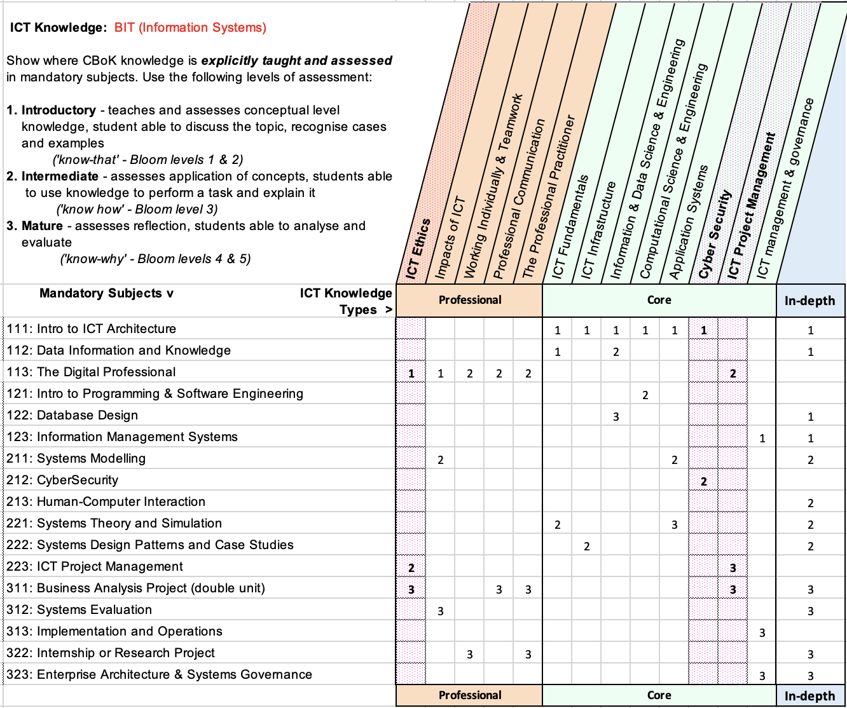

SAMPLE

a) CBoK Professional Knowledge - ICT Ethics is considered a key professional attribute (see the ACS Code of Ethics). Ensure that it is taught and assessed at least at intermediate level (Bloom level 3).
Skills in working 'individually and teamwork', and 'professional communication' should also be Intermediate level, Bloom level 3.

b) CBoK Core Knowledge - Knowledge of ICT Project Management and Cyber Security are considered key professional attributes. Ensure they are taught and assessed at least at Intermediate level, Bloom level 3.
Explain the profile of coverage of the other CBoK Core Knowledge major topics with respect to the professional role the program addresses.

c) CBoK In-Depth Knowledge - The in-depth column demonstrates the building of knowledge within the relevant ICT discipline and towards the advanced subjects (Criterion D). Identify external disciplinary curricula and bodies of knowledge to provide a justification for the CBoK In-Depth Knowledge being taught. See the CBoK for a range of resources.
The CBoK section 3.3 describes the relationship between Core ICT knowledge and ICT related Bodies of Knowledge, including the Data Science BoK, the Business Analysis BoK, etc. No related bodies of knowledge fully cover the CBoK, so a program based solely on a related body of knowledge will not in itself satisfy the breadth of ICT knowledge requirements (Criterion C). In addition, many related bodies of knowledge contain subjects beyond the scope of CBoK (for example, Statistics in the case of Data Science BoK, Organisational Behaviour in the case of Business Analysis BoK) and these subjects do not count towards the required volume of ICT knowledge (Criterion A).

Criterion D. Advanced ICT Knowledge Addressing Complex Computing

Review the requirements for advanced ICT knowledge to address complex computing in the Accreditation Manual, Volume 2, Criterion D.

In the table below:
Identify subjects that are assessed at an advanced level that are targeted specifically at the professional role identified for this program (exclude the advanced subjects used in Criterion E).
Identify the assessment item(s) that assess ICT knowledge at an advanced level (eg. at least Blooms level 4).
Then explain which Seoul Accord criteria of complex computing are addressed by each assessment item (see Criterion D in Volume 2 of the Accreditation Manual).

D. Advanced ICT Subjects Addressing Complex Computing
Subject Code & Title | Assessment Item | Complex Computing Criteria met

Criterion E. Integrated and Applied ICT Knowledge and Skills

Review the requirements for integrated and applied ICT knowledge in the Accreditation Manual, Volume 2, Criterion E.

Identify the advanced subject(s), often a capstone, that provide and assess the integration of knowledge and skills specifically targeted at the professional role identified for this program.

E. Integrated & Applied ICT Knowledge
Subject Code & Title | Notes in support of Claim

Criterion F. Preparation for Professional ICT Practice

Show how the program develops a well-rounded professional with respect to the attributes listed in the Accreditation Manual, Volume 2, Criterion F.

3.2 ICT Program Implementation Pathways

In this section of the template, link to any information needed to explain and justify any relevant aspects of the program implementation pathways referred to in
Section 3.2.2 of the Accreditation Manual Volume 2 Accreditation Criteria

Version History

Date | Document  Version | Revision History (reason for change) | Author /Reviser
2 Oct 2013 | 1.0 | Creation of original document
4 Apr 2014 | 1.1 | Formatting updates | Graham Low
10 Nov 2015 | 1.2 | Changes to section 3.2.3 | Graham Low
19 Feb 2016 | 2.0 | Version update in alignment with CBOK release | Berny Martinez
31 Jan 2019 | 4.0 Pilot | Complete revision: clarified criteria, aligned with TEQSA, simplified application | Craig McDonald
12 Aug 2019 | 4.2 Pilot | Minor revisions – interim pilot feedback | Craig McDonald
15 Dec 2019 | 5.0 | Incorporate feedback from pilot | Craig McDonald
15 Sep 2020 | 5.1 | Incorporate feedback – minor edits | Craig McDonald
30 Aug 2021 | 5.2 | Data Science specialisation – minor edits | Craig McDonald
30 Sep 2021 | 5.3 | Align with revised CBoK, refine specialisations | Craig McDonald
30 Dec 2022 | 5.3 | Minor edit to Criterion C | Craig McDonald

APPROVALS

Date approved | Version: | Approved By | Date in force | Next Review Date
15 Dec 2015 | 1.2 | Professional Standards Board | 15 Dec 2015 | n/a
19 Feb 2016 | 2.0 | Professional Standards Board | 19 Feb 2016 | n/a
1 Feb 2019 | 4.0 Pilot | Management Committee | 22 Feb 2019 | n/a
12 Aug 2019 | 4.2 Pilot | Rupert Grayston, Director PSAS | 13 Feb 2019 | n/a
29 Jan 2020 | 5.0 | Rupert Grayston, Director PSAS | 1 Feb 2020 | n/a
15 Sep 2020 | 5.1 | Rupert Grayston, Director PSAS | 15 Sep 2020 | n/a
30 Aug 2021 | 5.2 | Siobhan Casey, A. Director PSAS | 30 Aug 2021 | n/a
30 Sep 2021 | 5.3 | Siobhan Casey, A. Director PSAS | 30 Sep 2021 | n/a
30 Jan 2023 | 5.3 | Rupert Grayston, Director, Capability | 30 Jan 2023 | n/a

Custodian title &  e-mail address: | Rupert Grayston, Director, Capability  Rupert.Grayston@acs.org.au
Responsible Business Group: | Capability
Distribution: | Public document
Content Security: | N/A.

